

Neighbors say Dorchester fire victim was welcoming, kind

**By Steve Annear** Globe Staff, March 5, 2016, 7:18 a.m. **7**

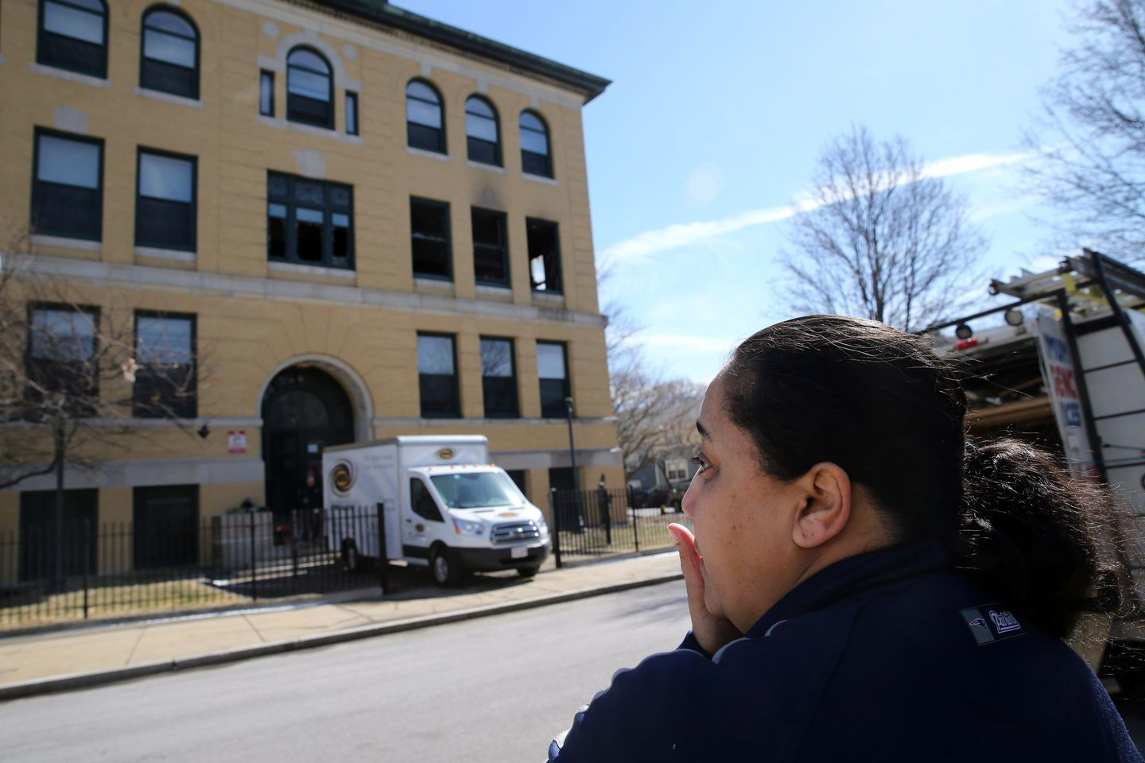

“It’s very sad. She was a very sweet woman,” neighbor Estella Sena said of the victim. “She was very friendly.” CRAIG F. WALKER/GLOBE STAFF

Some friends called her “Tonia,” while others simply knew her as “Ma,” for her welcoming and motherly personality.

But no matter what nickname was used when talking about the victim of a fatal Dorchester fire early

Saturday morning, those who saw her regularly in the would leave a void.

Codman

Square neighborhood said her death

The woman, whose name and age were not released by officials, was killed after a single-alarm fire broke out in her second-floor apartment at the old Girls Latin School at 380 Talbot Ave., around 3:50 a.m., fire officials said.

Derek Watkins, who identified himself as the victim’s nephew, said she was a kind person.

Advertisement

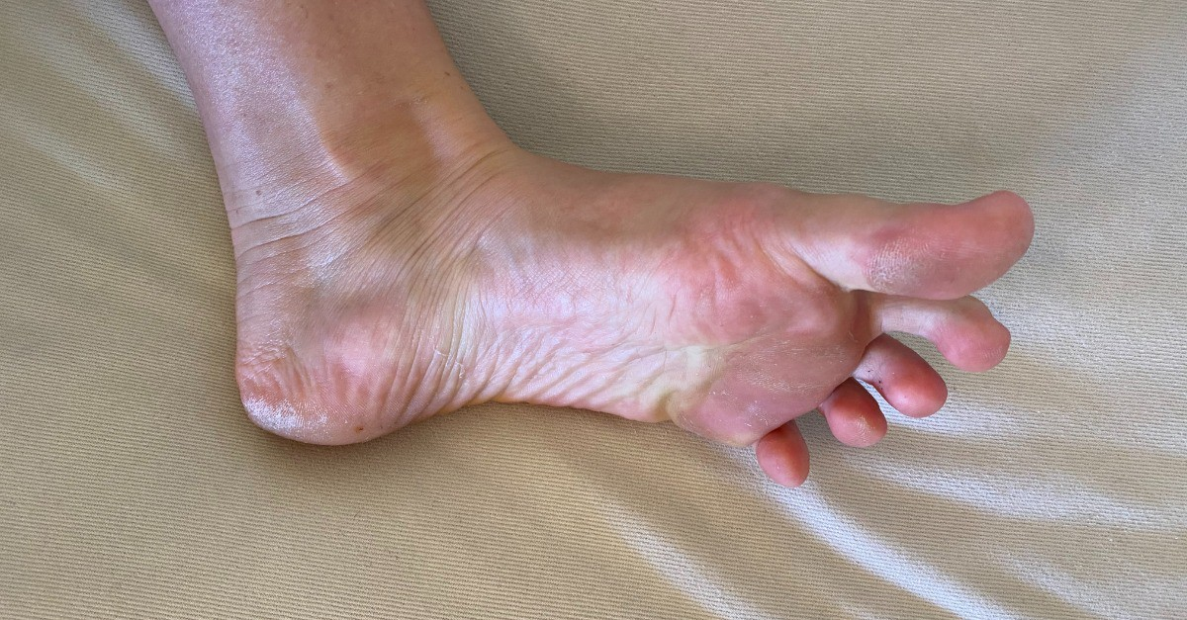

**4 Signs Your Heart Is Quietly Failing You**

Sponsored by PhysioTru

“I’m just devastated,” he said, looking up toward the shattered windows that exposed the burned-out apartment. “My heart is just broken right now.”

Too distraught to speak further, Watkins got into a car and left the scene.

The cause of the fire is still under investigation. The Office of the Chief Medical Examiner will determine a cause of death of the victim, Boston Fire Commissioner Joseph Finn said.

**Get Today's Headlines in your inbox** Enter Email

[example@email.com](mailto:example@email.com)

**Sign Up**

The day's top stories delivered every morning.

Firefighters who responded to the fire at the 54-unit building pulled the victim from the smoky apartment, where a significant blaze was contained to the living room area.

The victim was rushed to Boston Medical Center, where she was pronounced dead.

“They were able to get in the building quickly and were told there was a victim in the apartment, so they went to retrieve her. Sadly to say, she was pronounced dead,” said Finn, standing at the scene of the blaze hours after it was put out.

A worker peered through a broken window at the Latin Academy Apartments on Saturday. CRAIG F. WALKER/GLOBE STAFF

The woman’s death marked Boston’s second fire fatality this year, officials said.

John Rattler, 26, who lives one floor above where the fire occurred, described the woman who lived there as “very nice.” She would say “hi” to neighbors, he said, and often hold the door for people.

Advertisement

Rattler said he was woken up early Saturday by an alarm going off in the building. He didn’t take the situation seriously at first, he said, because there had been false alarms. But then he smelled the smoke wafting from the victim’s apartment.

“I heard someone yelling in the hallway, and I said . . . ‘We have to get out of here,’ ” said Rattler, who lives with his two young children and fiancée. “Thank God it wasn’t more than just that one apartment. But even that’s sad — I mean, she lost her life.”

Rattler said he shepherded his family into their car to keep warm, while other residents were shuffled onto MBTA buses for shelter as fire crews battled the blaze.

As workers cleared out the scorched apartment Saturday morning, friends and family stared up at the building in disbelief.

A woman who would only give her name as Ms. Brown said she had lived with the victim for two months during the summer. Brown said the victim, whom she called “Ma,” took her in when she fell on hard times, and that news of the woman’s death came as a shock.

“She was lovable. If you needed anything, if you were hungry — she would cook and give you food. Whatever it is. If you needed a dollar or two dollars, whatever it is she would give it to you,” Brown said.

Brown described the victim as someone who was easy to talk to and the two would stay up all night and talk about everything from movies to “life in general.”

Advertisement

“She used to tell us about her past. All types of things,” Brown said.

Estella Sena, who has lived in the building for seven years, shared light conversation with the victim and knew her as “Tonia.”

“It’s very sad. She was a very sweet woman,” Sena said. “She was very friendly.”

Kyle Tonge, who, like Brown, said the victim had helped him in a time of need, said her spirit could make people laugh.

He, too, called her “Ma.”

“From the first time I met her, she was just friendly,” he said. “Just good vibes.”

Aimee Ortiz of the Globe staff contributed to this report. Steve Annear can be reached at [steve.annear@globe.com. Follow him on Twitter @steveannear.](mailto:steve.annear@globe.com.FollowhimonTwitter@steveannear)



**Show comments**

# BOSTON GLOBE VIDEO

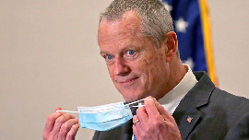

2:23

Baker announces ‘VaxMillions’ lottery program SHARE

Governor Charlie Baker announced residents who are fully vaccinated against COVID-19 will have the chance to win $1 million in a special Lottery sweepstakes. (Photo by Matt Stone/Boston Herald via AP)

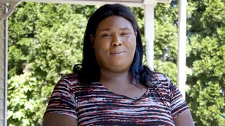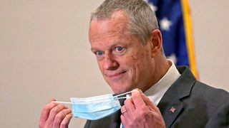

**Baker announces ‘VaxMillions’ lottery program**

**NOW PLAYING**

**Moose spotted on Route 3 in Chelmsford**

**What Black liberation means to me: Athena Vaughn**

**SEE MORE VIDEOS**

**MOST POPULAR ON BOSTONGLOBE.COM**

1. Life sciences is poised to be Boston’s dominant industry. Has the area become the Silicon Valley of biotech?
2. Some lawmakers want to ban critical race theory in schools. So, what is it?
3. Is there something wrong with the air in South Portland, Maine?
4. ‘My Name Is Bulger’: Two brothers, one documentary, an only-in-Boston story
5. How Massachusetts communities are celebrating the state’s first official Juneteenth
6. Coolidge Corner Theatre unveils plans for major expansion
7. Message in a bottle, tossed into the sea in Rhode Island, found in Azores
8. A power play? Steam plant owner aims to decarbonize downtown with huge building project
9. A treasure map for an American tyrant
10. The downside of ditching masks: the return of colds, flu



**VIEWS FROM OUR COLUMNISTS**

**YVONNE ABRAHAM**

Energy efficiency is a low-hanging fruit to combat climate change. So why can’t everyone get access to it?

**KEVIN CULLEN**

Bill Bratton on American policing and the challenge facing the Boston Police Department

**THOMAS FARRAGHER**

A salute across the ages to an old squad leader

**SHIRLEY LEUNG**

A working mother’s manifesto: Pandemic provides a once-in-a-generation chance to course correct how we work

**JENEÉ OSTERHELDT**

The pride I carry with me: Karim

**ADRIAN WALKER**

‘The best Boston movie no one’s ever seen’: ‘Blue Hill Avenue’ at 20

**MORE ON GLOBE.COM**

# SPONSORED BY: SUB- ZERO, WOLF, AND COVE

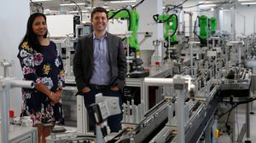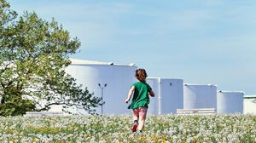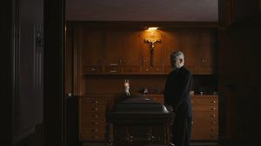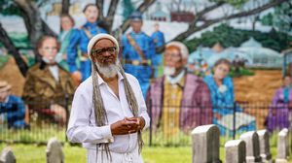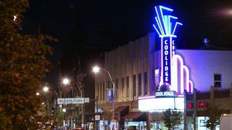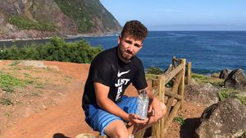

## Outfit your designer kitchen with this guide to high-end appliances

From choosing a cooktop to refrigeration options, learn how to select the right style for your space.

# INNOVATION ECONOMY

## Life sciences is poised to be Boston’s dominant industry. Has the area become the Silicon Valley of biotech?

Since December, you can find six major indications that Boston is the undisputed center of the life sciences industry, a place where ideas and products that change — and save — people’s lives around the world originate.

# THE GREAT DIVIDE

## Some lawmakers want to ban critical race theory in schools. So, what is it?

As national debate over race-related curriculums rages on, here is a lesson on the subject and the controversy surrounding it.

# GLOBE MAGAZINE

## Is there something wrong with the air in South Portland, Maine?

Residents have lived near more than 100 massive petroleum storage tanks for decades, never really knowing if they’re breathing in dangerous chemicals. Now they’re fighting to find out.

## ‘My Name Is Bulger’: Two brothers, one documentary, an only-in- Boston story

The Discovery+ film offers an unusually intimate view of Whitey and Bill Bulger.

## How Massachusetts communities are celebrating the state’s first official Juneteenth

For more than a century, Juneteenth was a Texan holiday, then a Southern holiday, commemorating the anniversary of June 19, 1865, when General Gordon Granger of the Union Army told formerly enslaved people in Galveston they were free. Now it will be celebrated for the first time across the Commonwealth as an official state holiday.

## Coolidge Corner Theatre unveils plans for major expansion

Brookline officials are reviewing a proposed expansion of the landmark Art Deco cinema that will add two new screens — and over 200 seats — as well as a larger lobby and third-floor community space, with a catering kitchen and outdoor roof deck.

# RI NEWS

## Message in a bottle, tossed into the sea in Rhode Island, found in Azores

The note was written in 2018 by a 13- year-old who was visiting family in Rhode Island.

## A power play? Steam plant owner aims to decarbonize downtown with huge building project

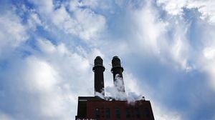

First the partners need to navigate the bureaucracy at the Department of Transportation, which controls the property at the heart of this proposal.

## A treasure map for an American tyrant

Donald Trump exposed weaknesses that a would-be dictator could exploit to end our democracy. It’s now up to lawmakers, voters, and public officials to prevent that from happening.

**MOST READ IN THIS SECTION**

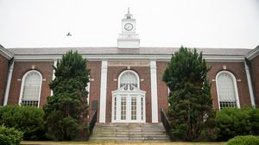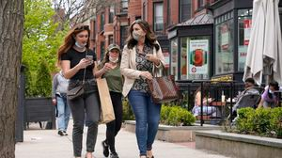

**THE GREAT DIVIDE**

**Some lawmakers want to ban critical race theory in schools. So, what is it?**

**GLOBE MAGAZINE**

**Is there something wrong with the air in South Portland, Maine?**

**How Massachusetts communities are celebrating the state’s first official Juneteenth**

**RI NEWS**

**Great white shark tagged in R.I. waters**

**RI NEWS**

**Message in a bottle, tossed into the sea in Rhode Island, found in Azores**

**Baker announces ‘VaxMillions’ lottery program, offering $1 million cash prizes to boost vaccination rates**

**UMass Lowell to remain closed Wednesday while investigating ‘cybersecurity incident’**

**The downside of ditching masks: the return of colds, flu**

# FOLLOW US

**SUBSCRIBE NOW MY ACCOUNT CONTACT MORE**

Digital Access / Home Delivery / Gift Subscriptions

Log In /

Manage My Account / Customer Service

Help & FAQs / Globe Newsroom / Advertise

Newsletters / View The EPaper /

Order Back Issues / News In Education / Search The Archives / Privacy Policy / Terms Of Service / Terms Of Purchase / Work At Boston Globe Media /

Do Not Sell My Personal Information

**METRO SPORTS BUSINESS & TECH OPINION**

WELCOME, JOHN

**TODAY'S PAPER**

**Summer Fitness Challenge Starts Monday**

Sign up now

©2021 Boston Globe Media Partners, LLC